**CREATE A CLOUD FUNCTION TO PULL A MESSAGE FROM PUB/SUB**

A Project Report Submitted in the fulfilment of the requirements for

Final-Project Evaluation

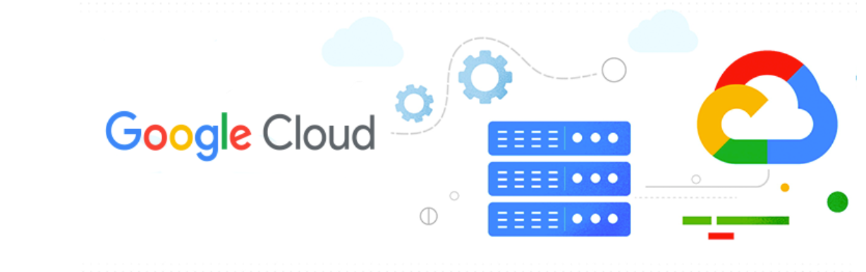

**A**

**2320738**

**GenC Intern**

**CONTENTS**

**INTRODUCTION**

**OBJECTIVE**

**SOFTWARE REQUIRED**

**PROJECT REQUIREMENT**

**IMPLEMENTATION**

**CONCLUSION**

**INTRODUCTION**

In the ever-expanding landscape of cloud computing, efficient data storage management is paramount for organizations to balance performance, accessibility, and cost-effectiveness. Google Cloud Platform (GCP) offers a comprehensive suite of storage solutions tailored to meet diverse needs, including Standard and Archive buckets, each optimized for specific use cases.

Google Cloud Platform (GCP) offered by Google, is a suite of cloud computing services that Provides a series of modular cloud services including computing, data storage, data analytics, and machine learning, artificial intelligence alongside a set of management tools.

GCP run on the same infrastructure that Google uses internally for its own products, such as Google Search and YouTube.

GCP is designed to be scalable, reliable, and secure. It is also cost-effective, with a pay-as-you-go pricing model.

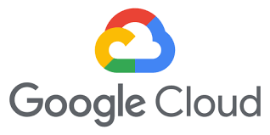

Here are some key points about GCP:

1. **Infrastructure and Services**: GCP offers a wide range of infrastructure and application services that can be accessed on-demand. It enables users to build, deploy, and scale applications seamlessly while taking advantage of Google’s powerful and reliable infrastructure.
2. **Global Resources**: GCP consists of physical assets (such as computers and hard disk drives) and virtual resources (such as virtual machines) distributed across data centers worldwide. These resources are organized into regions and zones, providing redundancy and reduced latency for better performance.

**Services and Integration**: When you develop applications on GCP, you combine various services to create the infrastructure you need. GCP services include compute, storage, databases, machine learning, and more. Additionally, GCP integrates seamlessly with other Google Cloud products.

**Benefits of using GCP**

There are many benefits to using GCP, including:

* **Scalability:** GCP can scale up or down to meet the demands of your application.
* **Reliability:** GCP is designed to be highly reliable, with a 99.9% uptime guarantee.
* **Security:** GCP is one of the most secure cloud platforms available, with a variety of security features to protect your data.
* **Cost-effectiveness:** GCP is a cost-effective cloud platform, with a pay-as-you-go pricing model.

Getting started with GCP is easy. You can create a free account and start using GCP services immediately.

To create a GCP account, visit the GCP website and click on the "Create an account" button. You will need to provide your name, email address, and a password.

Once you have created an account, you can start using GCP services. To learn more about GCP, you can visit the GCP documentation website.

Common use cases for GCP

GCP can be used for a wide variety of applications, including:

* Web and mobile applications: GCP can be used to host web and mobile applications.
* Data storage and analytics: GCP can be used to store and analyse data.
* Machine learning and artificial intelligence: GCP can be used to develop and deploy machine learning and artificial intelligence models.

**OBJECTIVES**

The objective of this project is to build a real-time stock price monitoring system that alerts users when a stock price crosses a certain threshold. The system will use Google Cloud Pub/Sub to stream real-time stock price updates and Google Cloud Functions to analyse and send alerts.

By accomplishing these objectives, this project aims to empower organizations to leverage GCP's storage capabilities effectively, driving operational efficiency, and enhancing data governance practices.

**REAL TIME USECASE :**

**Real-time Stock Price Monitoring**

Build a real-time stock price monitoring system that alerts users when a stock price crosses a certain threshold. Use Cloud Pub/Sub to stream real-time stock price updates and Cloud Functions to analyse and send alerts.

**Steps:**

* Subscribe to a stock price API or feed and publish updates to Cloud Pub/Sub.
* Use Cloud Functions to analyze incoming price updates and check for threshold crossings.
* Send alerts via email, SMS, or push notifications using Cloud Functions.

**SOFTWARE REQUIRED**

The software required for this project includes:

Google Cloud Platform (GCP) Account: Sign up for a GCP account if you don't have one already. This provides access to GCP's storage services, including Cloud Storage for creating buckets and managing data.

**Ways of interacting with GCP :**

GCP has four different channels to deal with the cloud resources.

**Web Console :**

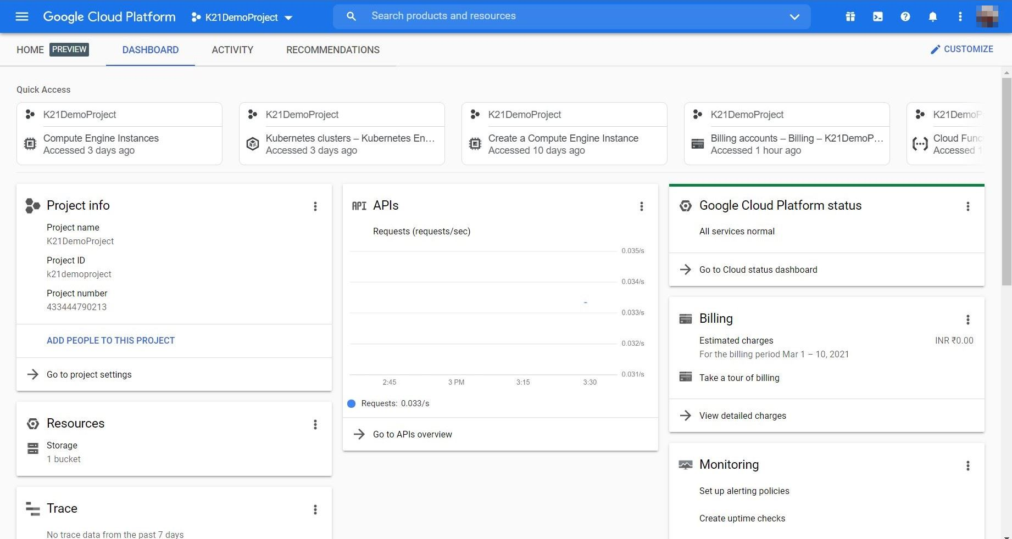

The first one is the Web Console. The moment you sign up with GCP, what you actually have is the web console and it is the front end, it is the gateway to dealing with a variety of services. As a beginner, you might want to spend more time with Web Console just getting yourself familiar with the navigation and understanding all the services offered by GCP.

**Cloud Shell and Cloud SDK :**

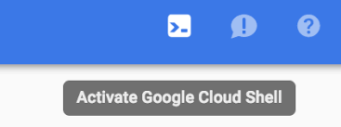

For administrators and DevOps engineers, there is a Cloud Shell and cloud SDK. So Cloud SDK comes with a CLI, a command line interface which can be used to launch a variety of resources and manage these resources. In fact, everything that you do with a web console can also be done from the command line. So Cloud SDK can be install in Linux, Windows and Mac machines. But one of the good things about using GCP is the availability of Cloud Shell. So Cloud Shell is a terminal built right into the browser. So without ever installing anything you can quickly interact with GCP by clicking a button

which is going to provision Cloud Shell for you. So Cloud Shell comes with pre-configured environment. It has all the tools that you need to launch resources, manage resources, and even some of the third-party utilities like Docker and so on.

**Mobile Application :**

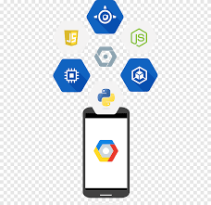

Then there is a Mobile App, this is very helpful to quickly access GCP resources. There are applications available in Google Play Store as well as Apple App Store.

So these are the four channels available to you.

The most popular and the most convenient Web Console, followed by the most powerful Cloud Shell/Cloud SDK which is the command line.

Then the convenient Mobile App and the Programmable REST API.

**Google Colab :**

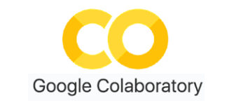

Google Colab (short for Collaboratory) is a cloud-based Jupyter notebook environment that allows you to write and execute Python code. It’s particularly useful for data science, machine learning, and collaborative projects. Here are some tips related to copying and pasting in Google Colab.

**PROJECT REQUIREMENTS**

**Pub/Sub :**

Google Cloud Pub/Sub is a managed service to ingest data at scale. It is built using the published subscribe pattern where you have a set of publishers that send messages to a topic, and there are a set of subscribers that subscribe to the topic, and Pub/Sub provides the infrastructure for the publishers and subscribers to reliably exchange messages. Pub/Sub acts as a global entry point to GCP based analytics services. Whether you are ingesting elementary data logs or any of the data that is ingested into the Cloud. It is typically sent by a Cloud Pub/Sub. It acts as a reliable and simple staging location for data though Pub/Sub is not meant to be a durable data store. It can be used for staging data as it enters the Cloud and is waiting to get processed by either Cloud Dataflow or data pro. In fact, Pub/Sub can deliver the data to a variety of destinations depending on how the subscribers are configured. This is tightly integrated with services such as Cloud storage and Cloud Dataflow, where you can use Pub/Sub to store inbound data through - for real time processing through Dataflow or for historical dataset archival on Cloud storage. Cloud Pub/Sub supports at least once delivery with synchronous cross zone message replication. What this means is you actually geta highly reliable delivery mechanism based on Pub/Sub, and there is redundancy because of cross zone message replication. You don't lose messages when it is sent via Cloud Pub/Sub infrastructure. Unlike most of the services of Google Cloud platform comes with end to end encryption, integration with identity and access management, and audit logging. So all these capabilities give you additional mechanism to secure and also monitor the inbound data coming where Cloud Pub/Sub.

**Cloud Functions:**

It's a serverless execution environment for building and connecting cloud services. So serverless computer environment is a mechanism where you don't have to provision and configure resources beforehand. This is fundamentally different from the way you deal with app engine, compute engine or even Kubernetes engine. For each of those you got to provision resources beforehand. You need to create app engine instances you need to launch VMs. We need to create a cluster, even before you can run your first line of code. But that's very different when it comes to cloud functions. In cloud functions, you write code

as a function, which has a well-defined entry point and exit point, and you deploy that with no changes. That's the reason why it is called as a serverless compute environment where you don't have to provision a virtual machine or a container, to run your code. It typically, serverless compute environments respond to events.

So instead of running this code forever, they get executed only when there is an external event. For example, adding a new object to a storage bucket or dropping a new message to the pub Sub queue, or for that matter, invoking a hit HTTP endpoint which will result in executing the serverless code. So any of those can be considered as the external event responsible for triggering the code. You can write cloud functions in JavaScript, Python 3, and Go. You don't have to package them in a specific format. At the most it's a zip file that gets into GCP environment

and starts executing against events. GCP events fire a cloud function through a trigger. So trigger is what connects the external resource to a cloud function.

An example event could be adding a new object to a storage bucket, a classic use case in this scenario is converting high resolution images uploaded to Google Cloud storage to thumbnails. So every time a new high resolution image is added

to a storage bucket, it triggers a cloud function and using an image manipulation library, it gets resized into a thumbnail and put in a different storage bucket. It this happens every time a new high risk image is added to the storage bucket. This is one of the most efficient and economical way of running code in the cloud. Triggers connect events to the function. So there is a trigger and there is an event and a function. So you define an event and you connect it to the function, and every time the trigger takes place it invokes the function via the event. So this is the environment that is very useful for executing code, which is written as code snippets or functions, and that's one of the reasons it's called as functions as a service or FAAS.

**IMPLEMENTATION**

Firstly, we are creating a topic named as “final-demo” with default subscription.

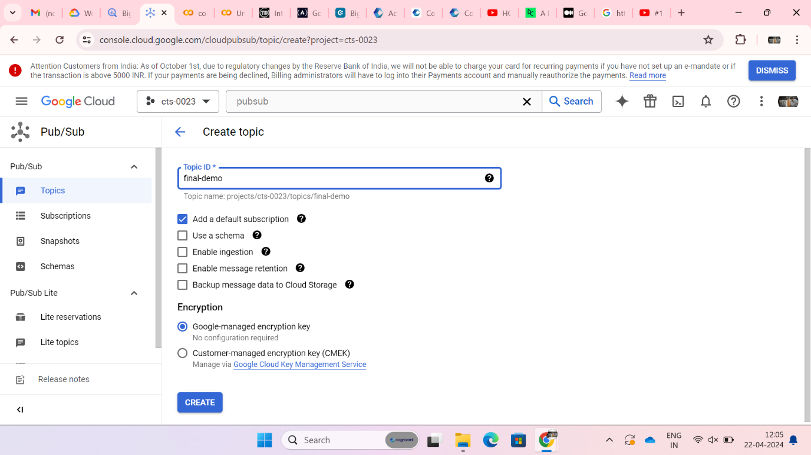

Here, default subscription is named as “final-demo-sub”.

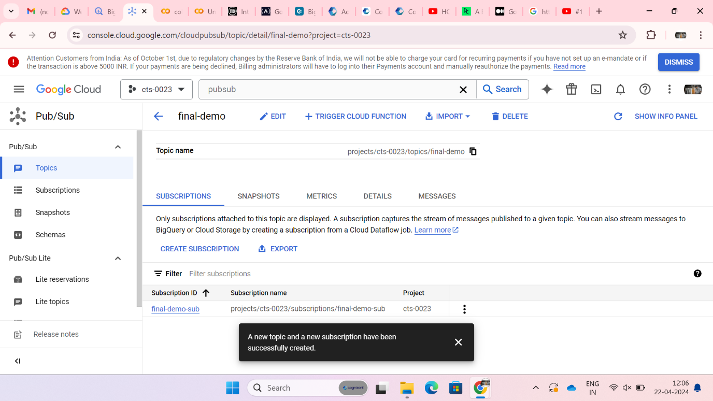

The topic named “final-demo” is created successfully.

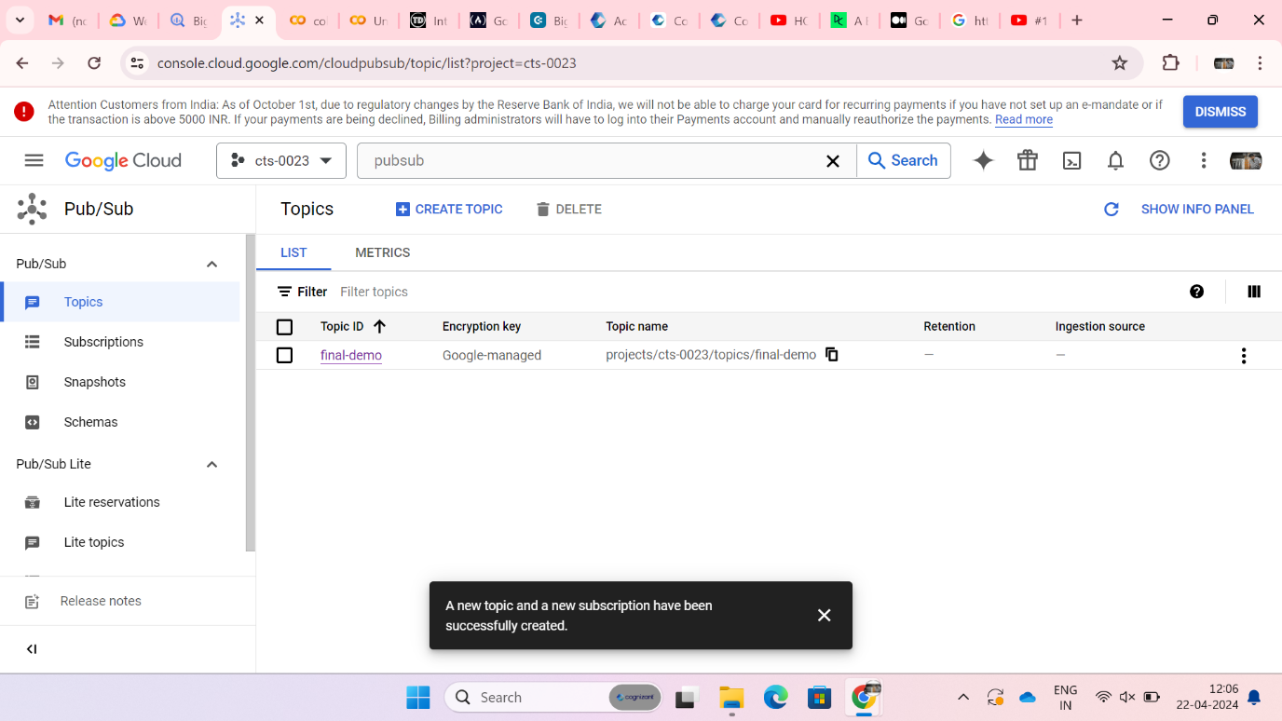

This command installs the google-cloud-pubsub package which is a client library for Google Cloud Pub/Sub.

